1.For the binary tree represented as an array, perform in-order threading on the tree



|  |  |
| --- | --- |
| 2. Find the | Optimal Binary Search Tree for the : |
| Identifier  Where *n* | set {a1, a2, a3} = {do, if, while}  = 3 and |

Probabilities of successful search as {p1, p2, p3} = {0.5, 0.1, 0.05} and Probability of unsuccessful search as {q0, q1, q2, q3} = {0.15, 0.1, 0.05, 0.05}.

3. Find the MST for the graph given using Kruskals Algorithm and show all the steps.

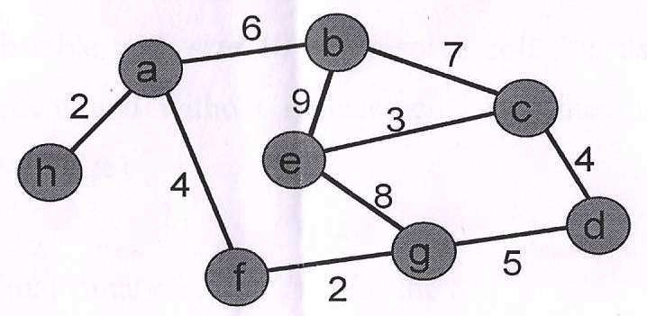

4. Create Min Heap (Binary) for

10, 12, 1, 14, 6, 5, 8, 15, 3, 9, 7, 4, 11, 13

After creating Min Heap delete element 1 from Heap and repair it.

Then insert element 20 and show final result.

5. Write a short note on Topological Sorting.

6. Define DFS and BFS for a graph. Show BFS and DFS for the following graph with starting vertex as 1.

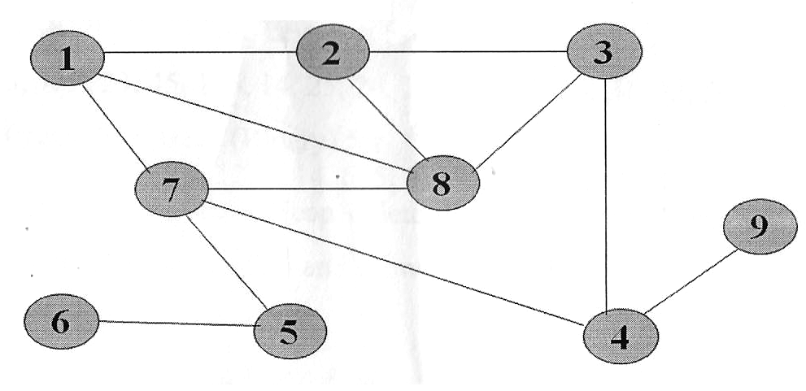

7. Write a program in C++ to count and display leaf nodes of binary tree.